Series: Mark: Jesus, God’s Servant King! First Baptist Church
Topic: Fruit, Evangelism, Kingdom of God Pastor Jim Barnes
Text: Mark 4:35-41 April 28, 2024

What Should I Do When Life Gets Rocky?

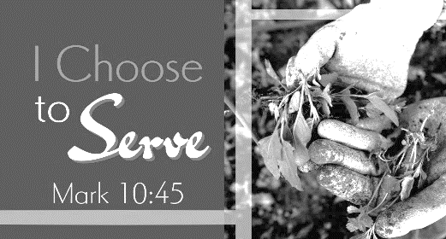
3 __________ That Will Help You When You Go Through Storms Turn In ________ To Jesus Who ___________ Even The Waves.

I. E_______ The __________ Of Life Will _____________ (Mark 4:35-37).

- Being A Christian Does Not _________________ You From Storms.

- Being A Christian Does Not Mean Jesus Will _________________ Your Storms.

- Being A Christian Means God Has A ________________ For ______________ Storms.

II. N_______ Allow Yourself To _______ God’s __________ (Mark 4:38).

- Know Jesus Is ____________ In Your ____________.

- Know Jesus _________________ About You – Even When It Seems He Doesn’t.

- Know Jesus Is The ___________________ Of Peace.

III. F_____ Fear Of ______________ With Fear For ____ (Mark 4:39-41).

- Jesus Shows You He Is The _________________ – __________________.

- Jesus Shows You His _____________________ To _____________________.

- Jesus Shows You He Is ___________________ To Be ____________________.

Application:
When life rocks your boat – who will you turn to – who will you put your trust in?

Only Jesus can calm the waves of your heart even when the storm is raging all around you and give you peace.

* Sermon Graphics Courtesy of Noel Merritt

